1. **The Anatomy of Typography**

**Serif Font**

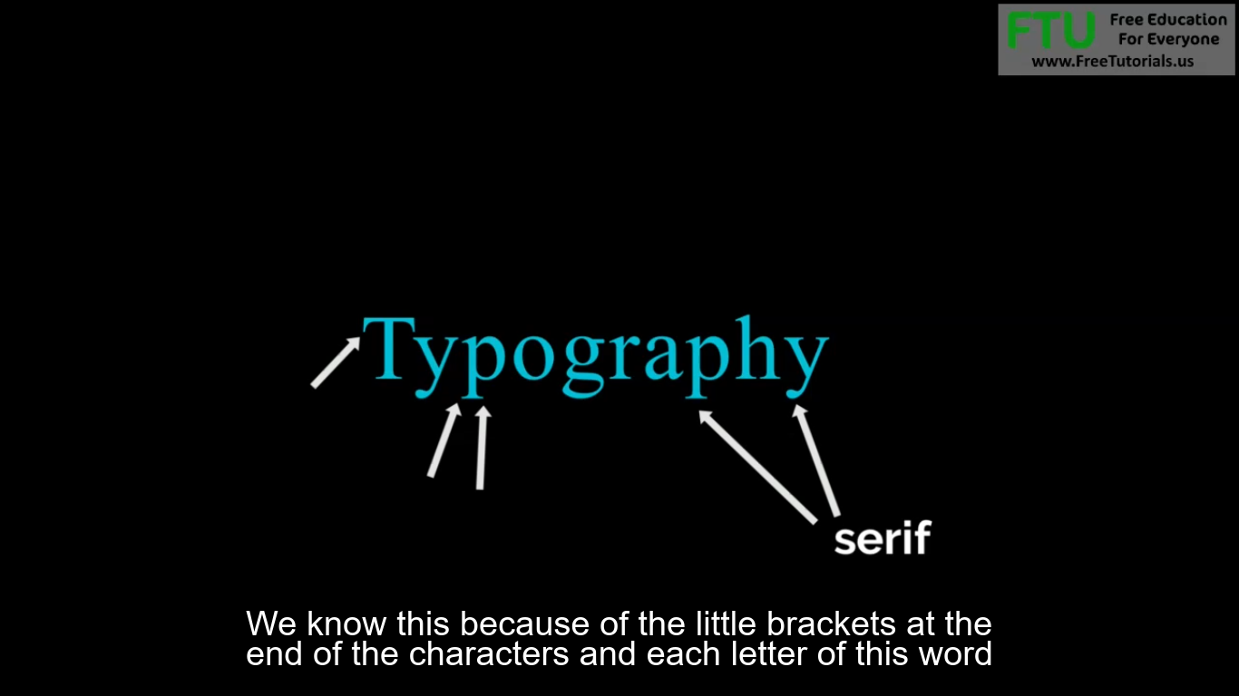

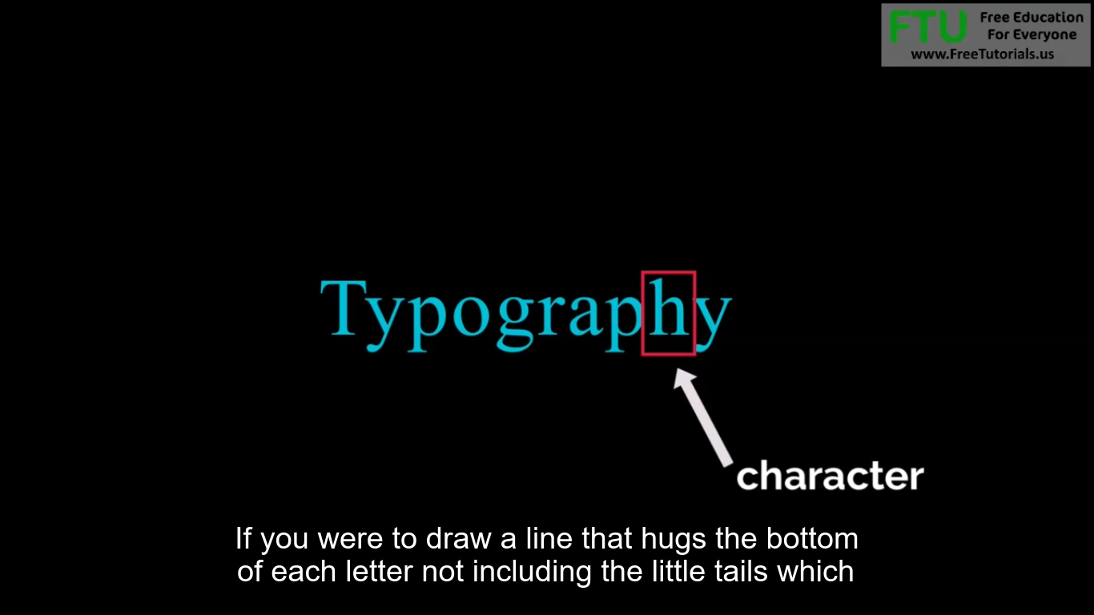

If you were to draw a line that hugs the bottom of each letter not including the little tails which

are called the dissenters this line would be called your baseline.

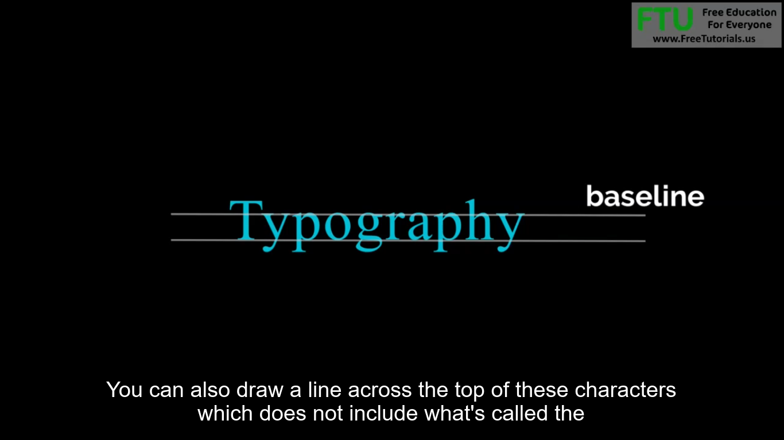

You can also draw a line across the top of these characters which does not include what's called the Ascenders

AsceEnders are this little area right here and then you can draw your second base line what are between

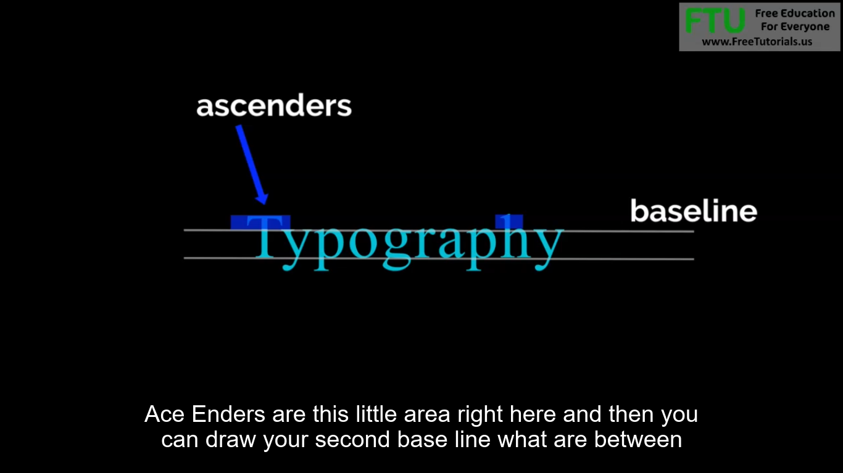

These two lines is the very core of your word or character and this can help you find balance in your type.

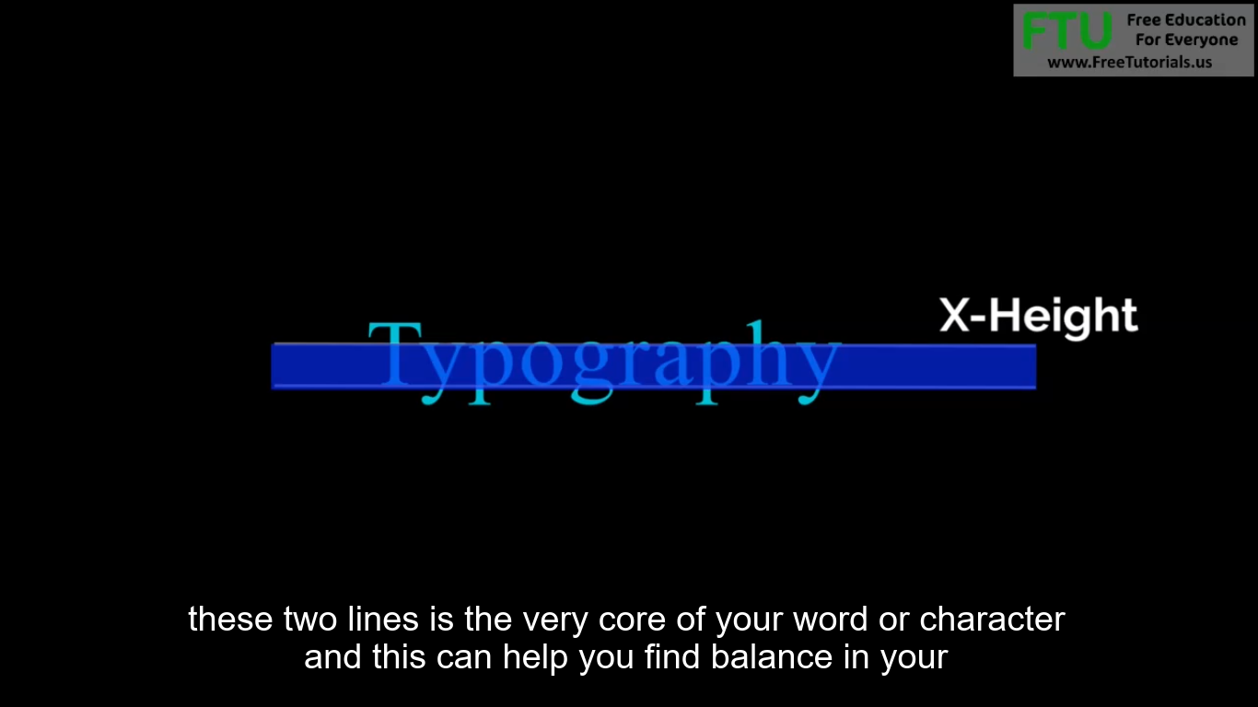

You may find you have more ace ending than descending characters and this revelation can help you decide

how to balance this type in a headline or a logo.

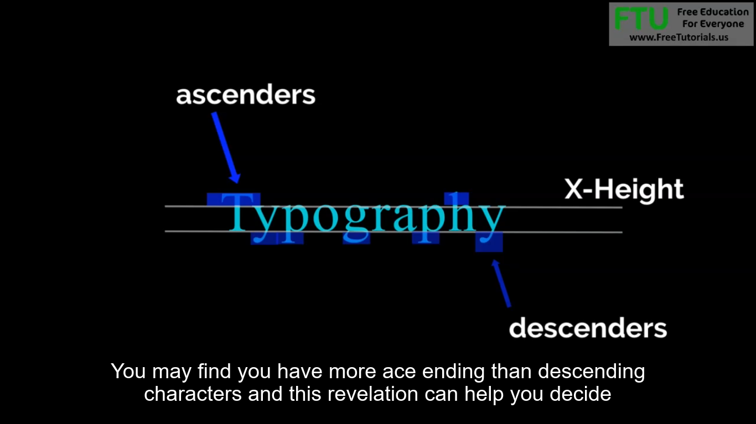

For example the line that can be drawn at the top on the tip top of your Ace Enders is called The Ascent Line

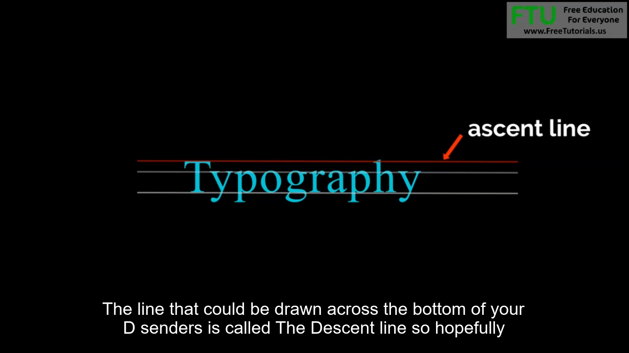

The line that could be drawn across the bottom of your D senders is called The Descent line so hopefully

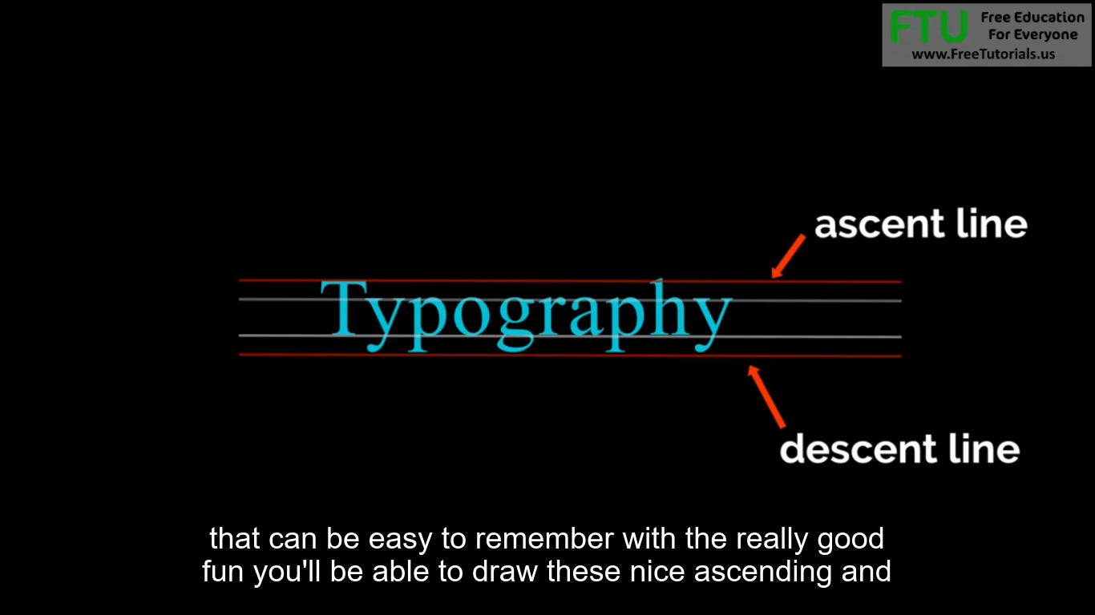

**Script Fonts**

Script fonts like this one don't always follow this nice line pattern.

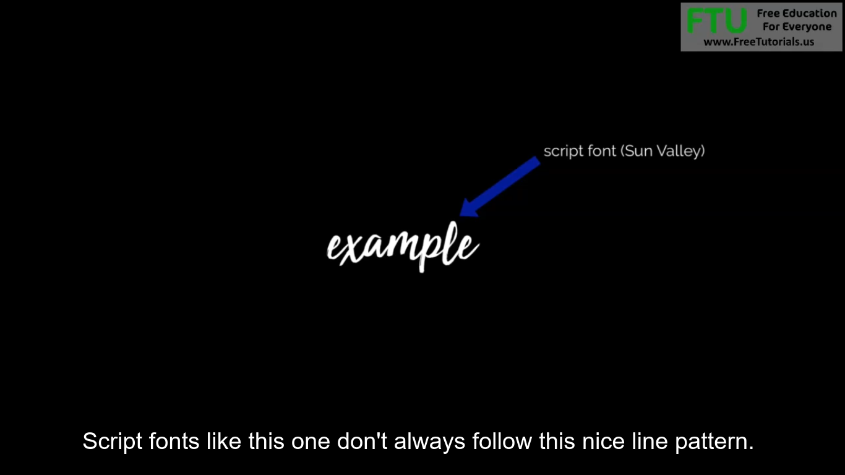

**Now let's go over some basic typography vocabulary.**

The tail is the very tip of the character.

The dissenter area which we now know takes up the bottom half the tail is just the very tip of that character

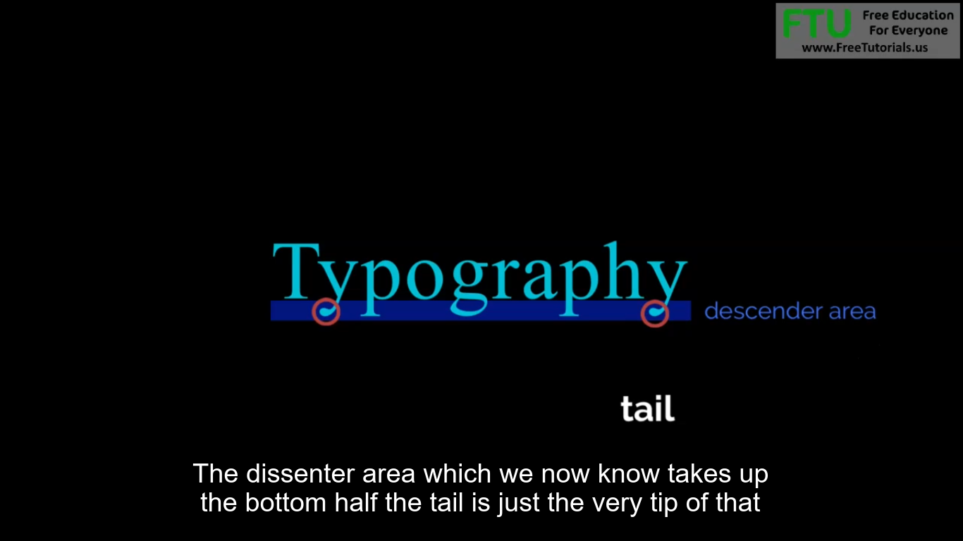

This is an example of the stem of the character

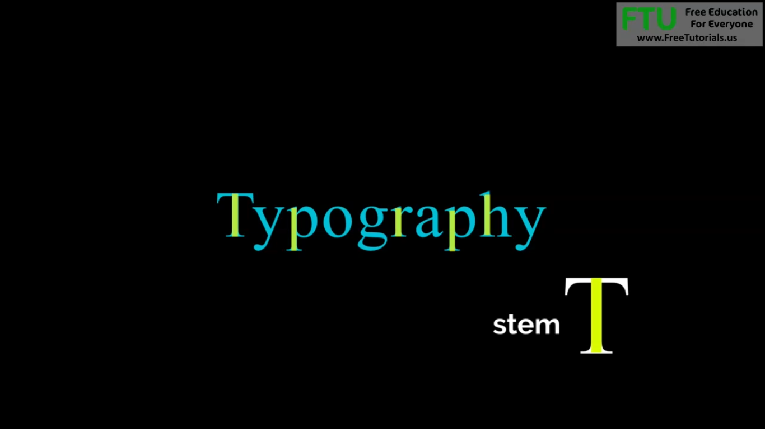

ears or anything that expands outside of the character.

Like in this example of the G

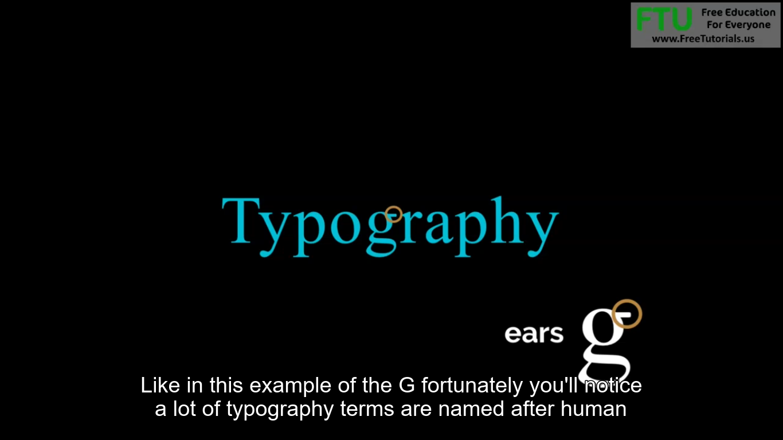

fortunately you'll notice a lot of typography terms are named after human

anatomy

So as you can guess this H is a great example of a shoulder

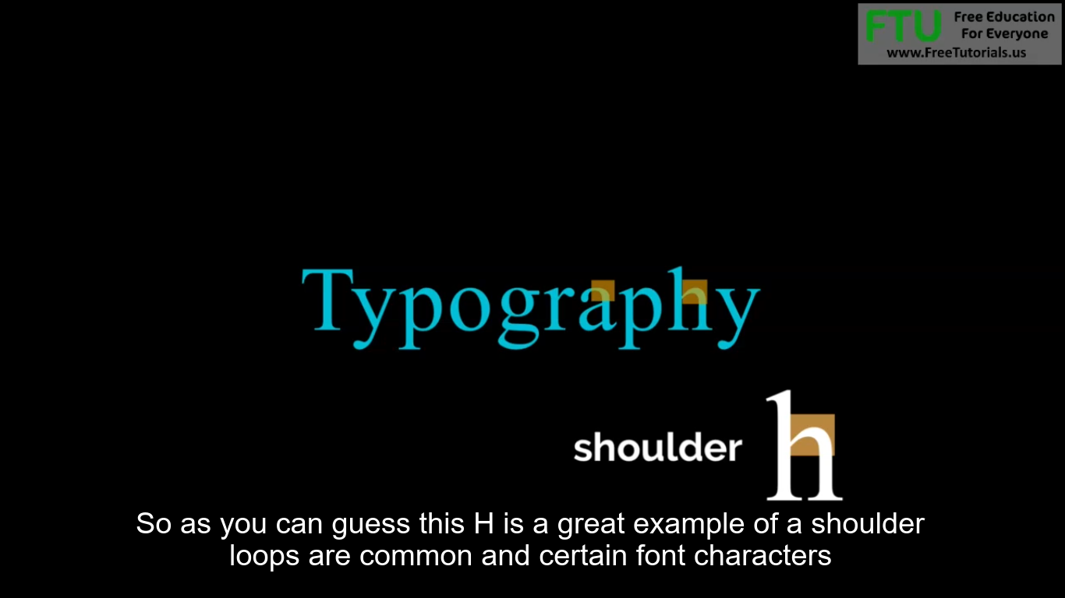

loops are common and certain font characters

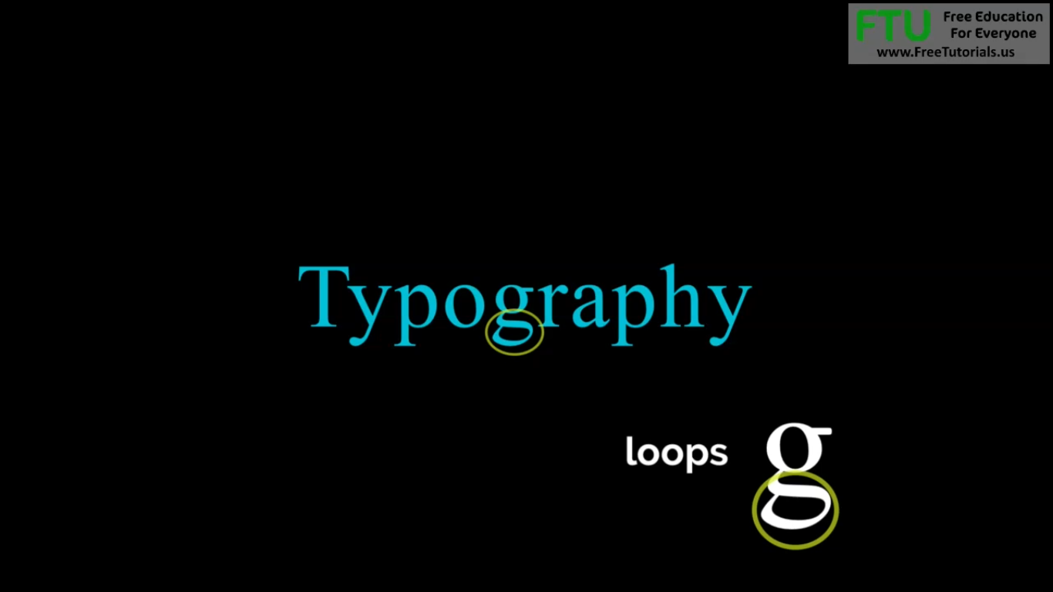

anything that's completely closed inside a character is called a closed counter

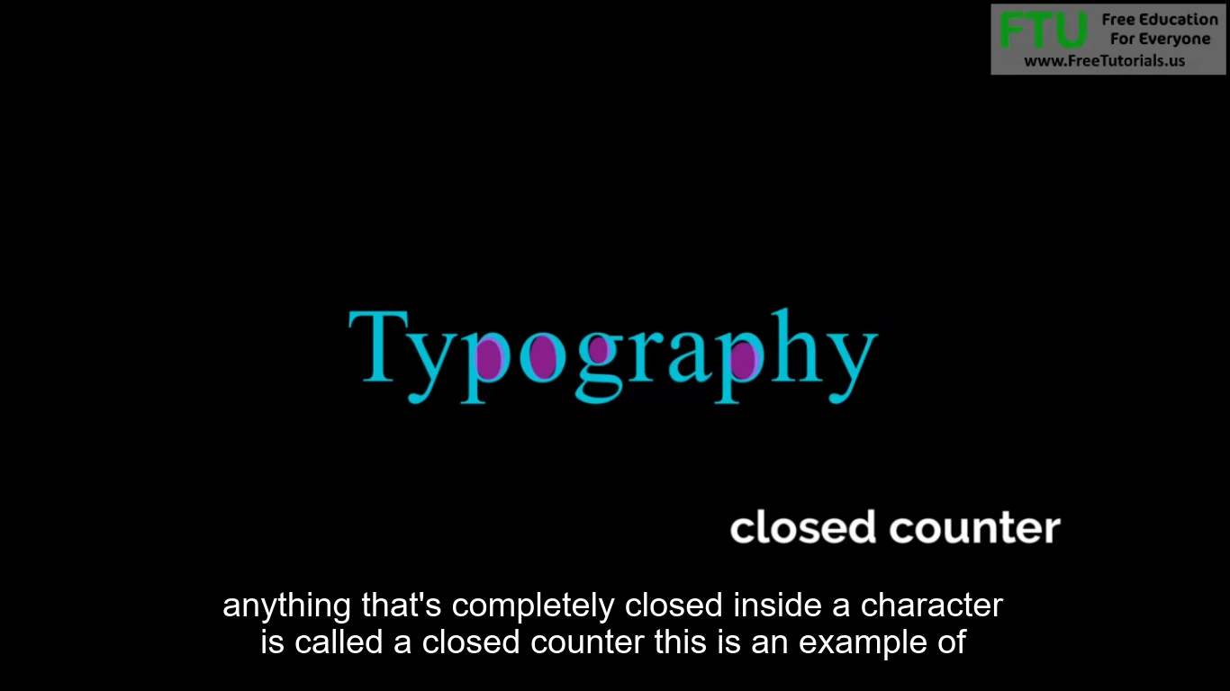

this is an example of a character leg cross bars join two stems together

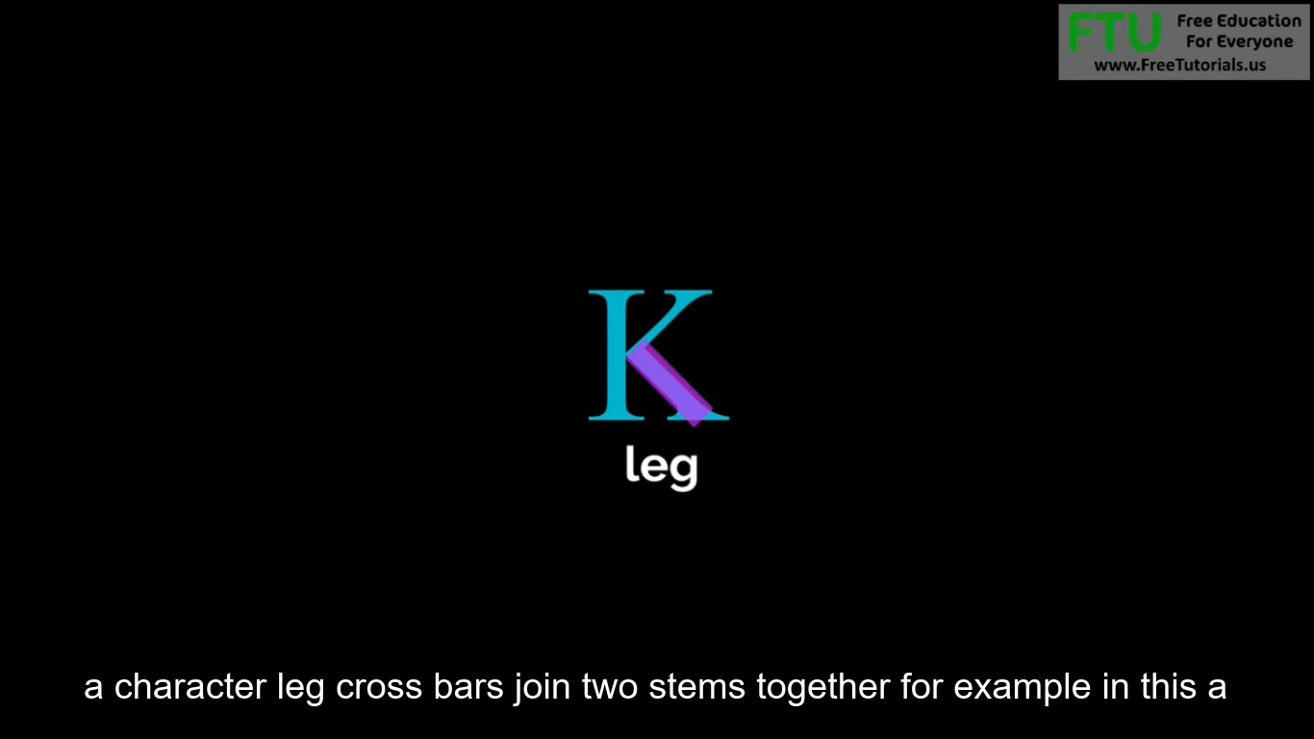

for example in this a

